Sumo


Report EUR xxxxx EN

1 New Functionalities 3
1.1 Analysis with Ice shapefile 3
1.2 Batchmode with a file list 3
1.2.1 Analysis with Ice shapefile 3
1.4 Functionality description 5
1.5 Single Analysis in Batch Mode 5
1.6 Multiple Analysis in batch Mode 5
1.7 Configuration Files 6
1.7.1 Global Configuration file 6
1.7.2 Local Configuration file 6
1.7.3 Ouput 7
1.7.4 Workflow 8
1.8 Import -> Coastline 8
1.8.1 First installation 9
1.8.2 Use new shape File 9
1.8.3 Old Land mask function 9
1.9 New XML output 10
1.9.1 XSD schema for new XML 10
1.10 New look-up tables and ENL values for S1 13
1.11 Geolocation using Orbit state vector (now only for S1) 14
1.12 Azimuth Ambiguity 14
1.12.1 “Twin peaks” Artefacts Ambiguity for S1 15

New Functionalities
This new release includes this new main functionalities:
- Analysis with Ice shapefile (First version)
- Batchmode with a file list
- First version of multithreading batch mode

Analysis with Ice shapefile
Pixel identified as Ice are excluded from the analysis
Shapefile for Ice could be downloaded from the NOA service or importing a local file.

Using shape file with Multiple Analysis in batch Mode
To use ice shape files in a batch mode analysis new parameters was added in the configuration file.

New Configuration Files parameter
The multiple batch mode analysis use a file configuration as explained in a previous document
To add the ice shape file new params was introduced:

- Param: use_ice
Main param to use or not the ice shape file in the analysis
Possible values:
none: analisys without ice
single: use only one shp file for all images
repository: use a remote or local repository to find the correct ice shp file searching for date
- Param: ice_repository_site
Possible values:
local: to use a local repository
- Param: ice_repository_path
- Param: ice_pattern_name

#noaa
#%yyyyDDD% java date format yyyy=year DDD=day of year
#local remote
ice_repository_site=remote
ice_repository_path=http://www.natice.noaa.gov/pub/daily/arctic/%yyyy%/ice_edge/
ice_pattern_name=nic_autoc%yyyyDDD%n_pl_a.zip

Example:

#Default is none
#none=analysis without ice
#single=use only one shp file for all images
#repository=use a remote or local repository to find the correct ice shp file searching for date
use_ice=repository

#noaa
#%yyyyDDD% java date format yyyy=year DDD=day of year
#local remote
ice_repository_site=remote
ice_repository_path=http://www.natice.noaa.gov/pub/daily/arctic/%yyyy%/ice_edge/
ice_pattern_name=nic_autoc%yyyyDDD%n_pl_a.zip

Using Ice Shape file in Interactive mode
T

- To use a shape file Ice in interactive mode select the “Tools->Import Vector” function .

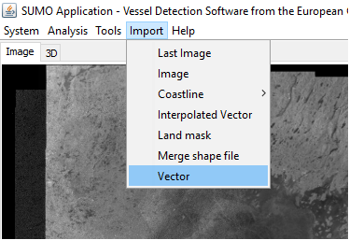

- From the dialog choose
Type: “shp”
Mask type: “ice”

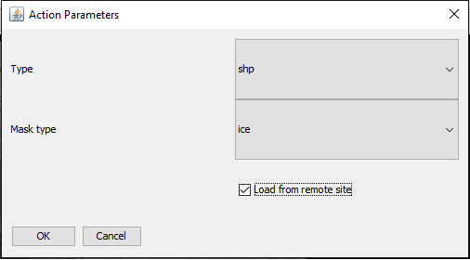

  - Single Analysis in Batch Mode

- Batchmode with File list
use_file_list=false
#input_file=list.txt
- Ice analysis improvements
Using the shape file to classify the ice pixels.

Functionality description
The batch mode , is a way to run the analysis without using the Sumo GUI. It can be used for single and multiple image analysis.

Single Analysis in Batch Mode
Example command line:
start_batch.bat -i "C:\ images\ S1A_IW_GRDH_XXSAFE\manifest.safe" -b 10 -thh 5 -thv 5 -tvh 5 -tvv 5 -sh "C:\land-polygons-split-4326\land_polygons.shp" -o C:\output

Command line params
- -i : image to analyze
- -thh , -thv , -tvh, –tvv : Thresholds array, optional
- -sh : shape file . Optional, if it is not passed Sumo try to use the default shape file .
- -o: output folder
- -b: buffer. Optional, if it is not passed Sumo try to use the default buffer.

Multiple Analysis in batch Mode

Command line parameters: the only one parameter required from the command line is the configuration file, each other parameters is specified in this file.

- -gconf : specify global file configuration

Configuration Files
For the multiple analysis we can use
- Global configuration file : for all images
- Local configuration file: to overwrite global parameters for a single image
This configuration files use “properties file” format:
propertyName=propertyValue
# comment

Global Configuration file
This file is specified from the command line with the –gconf params.
It contains all general parameters needed for the analysis and other configurations.

Example running command:

Parameters and configurations in the global configuration file
- thh,thv,tvh,tvv : thresholds values
- shape_file : path to the coastline shape file
- buffer : Coastline buffer
- input_folder : root folder that contains all images
- output_folder: root folder for the output

- use_local_conf:( true/false) If true , Sumo, search a local file configuration for each image

- force_new_analysis:( true/false) If true , Sumo, analyze also the images already analysed.

- filter:folder filter to select only some image

Global configuration file example:

#thresholds
thh=5
thv=5
tvh=5
tvv=5

#
shape_file=C:\\tmp\\land-polygons-split-4326\\land-polygons-split-4326\\land_polygons.shp
buffer=10
input_folder=C:\\tmp\\sumo_images\\carlos tests
output_folder=C:\\tmp\\output

#true/false
use_local_conf=true
force_new_analysis=true

#String filtering the image folder
filter=*CSKS*

Local Configuration file
The “local” configuration file is used to replace , when is needed, some global params for a single image.
If the option use_local_conf is setted to “true”, in the global configuration file, for each image the process will search a local file in the output folder.

To use a local file configuration we have to:
- Set use_local_conf=true in the global file
- Create the output folder for the image in the correct ouput path (the output folder have the same name of the input folder)
- Create the configuration file in the new output folder “analysis.conf”

Parameters avalaible in the local files:
thh,thv,tvh,tvv
shape_file
buffer

Example:
#local configuration analysis

#repleace the thresholds for hh
thh=5

#use another shape file
shape_file=C:\\tmp\\land polygon opsm 50m\\land_grid_buffer_50m.shp

#change the buffer
buffer=10

Ouput
Now the batch save always the analysis in the new and old xml format.
For the future, we’ll add the possibility to choose different output format.
One Shapefile for each band and a shape file for the merged layer
One global csv for the targets
One global csv for the bounding box

Workflow
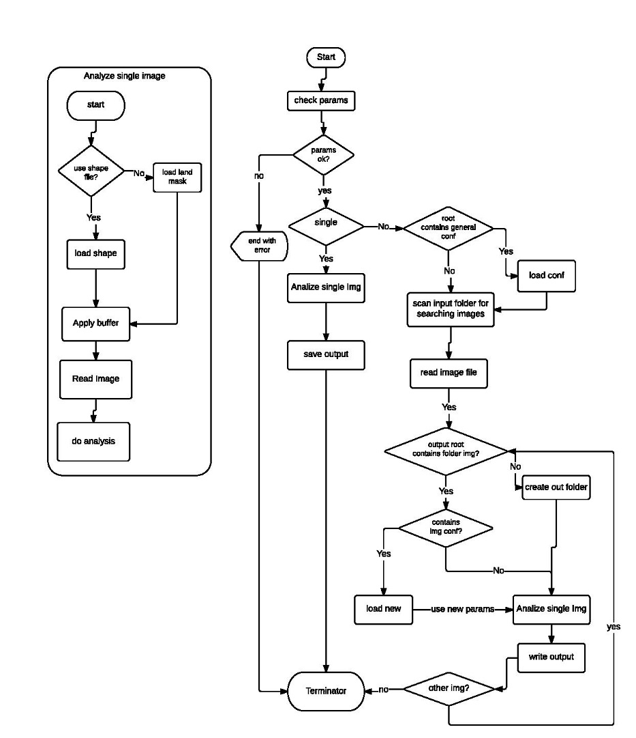

Import -> Coastline
With this new options we can add new shape files simply copying the shape file folder under the path configured in the preference “Coastline Shape folders”

- Menu: Import->Coastline -> “All shape file included in the configured folder”
The menu items are added dynamically , searching all valid shape files in the configured folder
- Preferences: Coastline Shape folders

First installation
To start using this new options, when Sumo start, check if under the menu Import the option “Coastline” is present. If no, you need to configure the preference “Coastline Shape folders” . The value of this preference is the path to the root folder that contains a subfolder for each shape file that we need.
- Preferences:
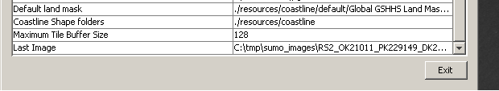

Use new shape File
Now to use a new shape file you can use the new option “import->coastline” or the old import function.
To use the new function you have to:
- Copy the folder that contains the shape file under
- Start (or re-start) Sumo
- Check if the new shape file is available under “import->coastline”
Example of Menu build on the folders below:
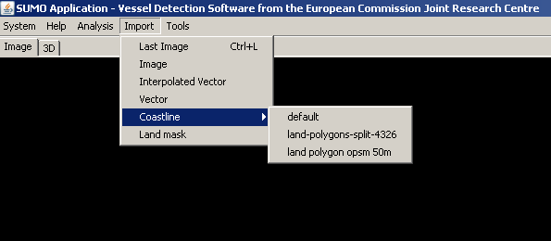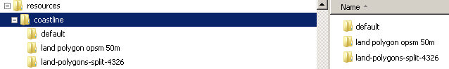

Old Land mask function
Previous: load shape file included in Sumo
Now: Import->Land Mask load the shape file configured using the “Default land mask” preference.

New XML output
Now we have two option to save the analys as XML :
- sumoXML Old : is the old Sumo xml format
- sumoXML : is the new XML format as specified in Harm document

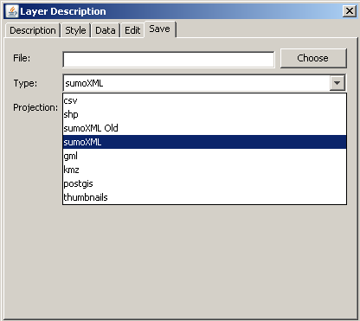

XSD schema for new XML
<?xml version="1.0" encoding="UTF-8" standalone="no"?>
<xs:schema xmlns:xs="http://www.w3.org/2001/XMLSchema" elementFormDefault="qualified">
<!-- analysis = xml root -->
<xs:element name="analysis">
<xs:complexType>
<xs:sequence>
<xs:element ref="sat_image_metadata"/>
<xs:element ref="vds_analysis"/>
<xs:element ref="vds_target"/>
</xs:sequence>
</xs:complexType>
</xs:element>

<!-- Corners with gcp -->
<xs:element name="gcps">
<xs:complexType>
<xs:sequence>
<xs:element maxOccurs="unbounded" ref="gcp"/>
</xs:sequence>
</xs:complexType>
</xs:element>
<!-- ground control point definition-->
<xs:element name="gcp">
<xs:complexType>
<xs:sequence>
<xs:element name="row" type="xs:int"/>
<xs:element name="column" type="xs:int"/>
<xs:element name="lon" type="xs:double"/>
<xs:element name="lat" type="xs:double"/>
</xs:sequence>
</xs:complexType>
</xs:element>

<!-- boat definition -->
<xs:element name="boat">
<xs:complexType>
<xs:sequence>
<xs:element name="target_number" type="xs:int"/>
<xs:element name="lon" type="xs:double"/>
<xs:element name="lat" type="xs:double"/>
<xs:element name="xpixel" type="xs:double"/>
<xs:element name="ypixel" type="xs:double"/>
<xs:element name="detecttime" type="xs:string"/>
<xs:element name="inc_ang" type="xs:double"/>
<xs:element name="inc_angle" type="xs:decimal"/>
<xs:element name="reliability" type="xs:int"/>
<xs:element name="false_alarm_cause" type="xs:string"/>
<xs:element name="nr_pixels" type="xs:int"/>
<xs:element name="length" type="xs:double"/>
<xs:element name="width" type="xs:double"/>
<xs:element name="size_class" type="xs:NCName"/>
<xs:element name="heading_range" type="xs:double"/>
<xs:element name="heading_north" type="xs:double"/>
<xs:element name="lwh_reliability" type="xs:boolean"/>
<xs:element name="manual_add" type="xs:boolean"/>

<xs:element name="rcs" type="xs:string"/>
<xs:element name="bgnd_mean" type="xs:string"/>
<xs:element name="bgnd_stdev" type="xs:string"/>
<xs:element name="bgnd_sigma0" type="xs:string"/>
<xs:element name="noise" type="xs:int"/>

<!-- format 0.000,0.000,0.000,0.000 significance values for the boat for each polarization -->
<xs:element name="significance" type="xs:string"/>

<!-- format 0.000,0.000,0.000,0.000 threshold values for the tile for each polarization -->
<xs:element name="threshold_tile" type="xs:string"/>

<xs:element name="max_value" type="xs:int"/>
<xs:element name="min_detectable_rcs" type="xs:string"/>

<!-- only for compatibility with the old code -->
<xs:element name="speed" minOccurs="0" type="xs:double"/>
<xs:element name="target_type" minOccurs="0" type="xs:string"/>
<xs:element name="comment" minOccurs="0" type="xs:string"/>
<xs:element name="related_target_number" minOccurs="0" type="xs:int"/>

</xs:sequence>
</xs:complexType>
</xs:element>

<xs:element name="algorithm">
<xs:simpleType>
<xs:restriction base="xs:string">
<xs:enumeration value="k-dist"/>
<xs:enumeration value="matrix"/>
</xs:restriction>
</xs:simpleType>
</xs:element>

<xs:element name="sensor">
<xs:simpleType>
<xs:restriction base="xs:string">
<xs:enumeration value="R1"/> <!-- Rsat1 -->
<xs:enumeration value="R2"/> <!-- Rsat2 -->
<xs:enumeration value="AS"/> <!-- Asar -->
<xs:enumeration value="CS"/> <!-- CosmoSkymed -->
<xs:enumeration value="TX"/> <!-- TerraSar-X -->
<xs:enumeration value="S1"/> <!-- Sentinel 1 -->
<xs:enumeration value="PZ"/> <!-- Paz -->
<xs:enumeration value="A2"/> <!-- ALOS-2 -->
<xs:enumeration value="P1"/> <!-- Pleiades -->
<xs:enumeration value="S6"/> <!-- SPOT6 -->
</xs:restriction>
</xs:simpleType>
</xs:element>

<!-- vds_analysis -->
<xs:element name="vds_analysis">
<xs:complexType>
<xs:sequence>
<xs:element name="run_time" type="xs:string"/>

<xs:element name="run_version" type="xs:string"/>
<xs:element minOccurs="0" name="run_version_num" type="xs:int"/>

<xs:element name="detector_version" type="xs:string"/>
<xs:element ref="algorithm"/>
<xs:element name="parameters" type="xs:string"/>
<!-- number of boats detected -->
<xs:element name="nr_detections" type="xs:int"/>

<!-- buffer for land mask used in vds_analysis -->
<xs:element name="buffer" type="xs:int"/>
<xs:element name="land_mask_read" type="xs:string"/>

</xs:sequence>
</xs:complexType>
</xs:element>
<!-- sat_image_metadata -->
<xs:element name="sat_image_metadata">
<xs:complexType>
<xs:sequence>
<!-- SS_yyyymmdd_HHMMSS SS=sensor yyyymmdd_HHMMSS=Time start -->
<xs:element name="ImId" type="xs:string"/>

<!-- for AC,CS sensor = file name without ext for R1,R2,TX,S1 = directory name -->
<xs:element name="image_name" type="xs:string"/>
<!-- UTC -->
<xs:element name="timestampStart" type="xs:string"/>
<xs:element ref="sensor"/>
<!-- Comma separated list of integers 1=HH 2=HV 3=VH 4=VV-->
<xs:element name="pol" type="xs:string"/>
<xs:element name="polnumeric" type="xs:string"/>
<!-- timestart yyy-mm-dd HH:MM:SS.FFF -->
<xs:element name="TimeStart" type="xs:string"/>
<xs:element name="TimeStop" type="xs:string"/>
<xs:element ref="gcps"/>
</xs:sequence>
</xs:complexType>
</xs:element>
<!-- targets -->
<xs:element name="vds_target">
<xs:complexType>
<xs:sequence>
<!-- targets is a list of boats -->
<xs:element maxOccurs="unbounded" minOccurs="1" ref="boat"/>
</xs:sequence>
</xs:complexType>
</xs:element>

</xs:schema>

New look-up tables and ENL values for S1

This are the new look-up tables added for S1:

TabK15217.r8
TabK15217X.r8
TabK26317.r8
TabK26317X.r8
TabK26817.r8
TabK26817X.r8
TabK27017.r8
TabK27017X.r8
TabK29717.r8
TabK29717X.r8
TabK50017.r8
TabK50017X.r8

Sentinel-1 ENLs to use in SUMO (Harm document)

The ENL to use in SUMO for Sentinel-1 images depends on the product.
The product is a combination of the mode (MM = EW, IW, S# or WV), the product type (PPP = SLC or GRD) and the resolution class (C = _ for SLC; F, H or M for GRD). For S#, stripmap (SM) mode, the beam # may be 1 to 6. These values are coded in the folder name of the image product:
S1A_MM_PPPC_1SDV_20141126T032112_20141126T032137_003447_00407B_4DCA.SAFE
for example:
S1A_IW_GRDH_1SDV_...
S1A_S1_SLC__1SSV_...

The ENL is not specified in the metadata, but it is specified in the S-1 documentation on the ESA web site.
For an SLC product, the ENL is always 1.
For the GRD products, the ENL can vary by beam. EW has 5 beams, IW has 3, and there are 6 SM beams. The beams in the IW and EW GRD products are all mosaicked into one image, so it is impossible to use a different ENL value for each beam. The default ENL value that SUMO presents to the user should therefore be a common one. However, a user might still want to analyse the (whole) image with an ENL that fits best to one of the beams in the image, leading to good results in only part of the image.
The SM beams are separate products, so each could use its own ENL; however, they are very close, so for practical reasons it is just as good to use the same value for all.
Look-up tables can unfortunately not be made for ENL values > 50, due to numerical instability in the integration (in the algorithm used at present for the calculation). Therefore, ENL = 50 must be used for all ENL values higher than that. The error introduced by that is small, and can be corrected if needed by using a lower manual threshold value (like 1.3 or 1.4 instead of 1.5).

The tale below gives the ENLs to use in SUMO for each product.

Product | EW_GRDH | EW_GRDM | IW_GRDH | IW_GRDM
ENL nominal | 2.8, 2.7, 2.7, 2.7, 2.7 | 15.2, 9.7, 9.5, 9.6, 9.6 | 4.4, 4.4, 4.3 | 83.9, 81.2, 80.5
ENL to use in SUMO | 2.7 | 9.6 | 4.4 | 81.0 → 50.0
 | exists | exists | exists | new
Product | S#_GRDF | S#_GRDH | S#_GRDM | ##_SLC
ENL nominal | 3.5, 3.5, 3.7, 3.5, 3.7, 3.5 | 26.8, 26.3, 29.7, 26.8, 29.7, 26.8 | >= 350 | 1.0
ENL to use in SUMO | 3.5 | 27.0 | 350 → 50.0 | 1.0
 | exists | new | new | exists

Ref:
https://sentinel.esa.int/web/sentinel/sentinel-1-sar-wiki/-/wiki/Sentinel%20One/Ground+Range+Detected
https://sentinel.esa.int/web/sentinel/sentinel-1-sar-wiki/-/wiki/Sentinel%20One/Level%201%20Product%20Formatting

Geolocation using Orbit state vector (now only for S1)

Project Geolocation

Azimuth Ambiguity

T=target
W= 250m X 250m windows builded at “Azimuth correction” distance and 2 X “Azimuth correction”

Max(T)=Max pixel value for the target
Max(W)=Max pixel value in the Window

Windows contain an ambiguity if Max(T)>10*Max(W)

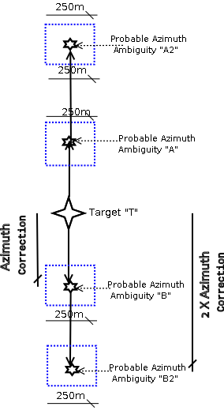

“Twin peaks” Artefacts Ambiguity for S1

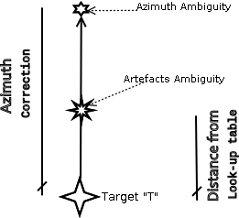


LB-NA-xxxxx-EN-N
ISBN xxx-xx-xx-xxxxx-x

